Connecting Windows 10 to FXNET_Secure

Problem:
Connecting to FXNET_Secure.

Problem Solution:
Follow the How To guide below.

How To:

1 - Open the list of available Wi-Fi networks. Highlight FXNET_Secure and click Connect. On the warning that then appears, click Connect.
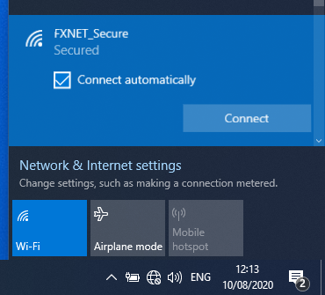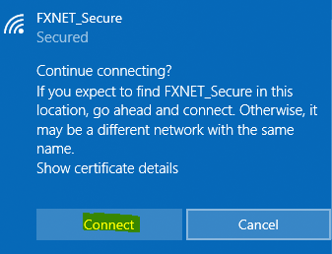

2 – De-select the ‘Use my Windows user account’ and enter your University username and password, click OK. On the warning that then appears, click Connect.

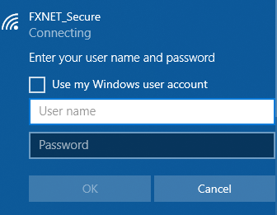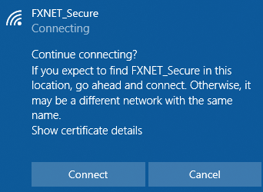

3 – Your WiFi will then show as connected to FXNET_Secure.

